BENISE: STRINGS OF HOPE
Premieres on PBS Stations Beginning February 27

– “The Prince Of Spanish Guitar” Captures World Music At Its Best –

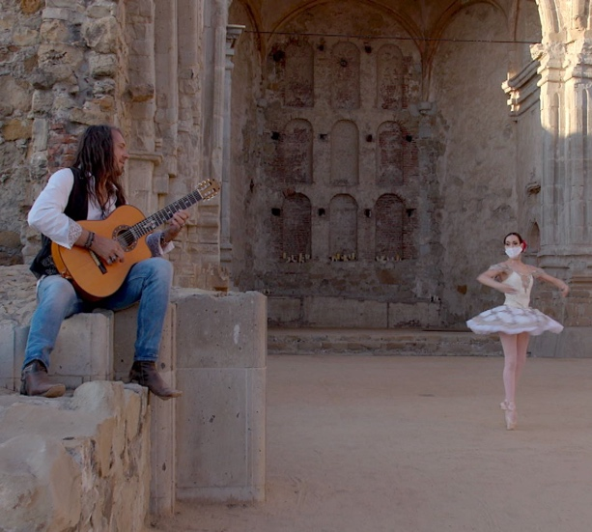
Credit:

At a time when we need the healing power of music more than ever, Benise provides a deeply personal selection of songs. Filmed in the “Ruins of the Sacred Church,” this new special features Benise performing eight new pieces and seven fan favorites that showcase his Emmy Award-winning stage production over the last 20 years. “The Prince of Spanish Guitar” adds his signature touch to classics such as “Ave Maria, “Moonlight Sonata,” “Clair de Lune,” Vivaldi’s “Summer” from The Four Seasons, “Stand By Me” and more. Capturing world music at its best, the program appeals to the hearts and souls of people of all ages, cultures and musical backgrounds. BENISE: STRINGS OF HOPE is part of special programming premiering on PBS stations beginning Saturday, February 27, 2021 (check local listings).

PBS special programming invites viewers to experience the worlds of science, history, nature and public affairs; hear diverse viewpoints; and take front-row seats to world-class drama and performances. Viewer contributions are an important source of funding, making PBS programs possible. PBS and public television stations offer all Americans from every walk of life the opportunity to explore new ideas and new worlds through television and online content.

Underwriters: Public Television Viewers and PBS
Producer: Spanish Guitar Entertainment

- PBS –

CONTACT: Cara White, CaraMar, Inc., 843-881-1480; cara.white@mac.com

For images and additional up-to-date information on this and other PBS programs, visit PBS PressRoom at pbs.org/pressroom.

